SMALL BUSINESS FINANCIAL HEALTH ANALYZER
A Project Report on Financial Statement Analysis and Financial Health Assessment of Agrawal Traders
Prepared By: Aanyaa Agrawal
B.A. Programme (Computer Applications + Economics)
Jesus and Mary College
University of Delhi
(2025-2028)

TABLE OF CONTENTS

- Introduction
- Objectives of the Project
- Business Profile – Agrawal Traders
- Financial Statements
  - Trial Balance
  - Trading and Profit & Loss Account
  - Balance Sheet
- Ratio Analysis
  - Current Ratio
  - Quick Ratio
  - Net Profit Margin
  - Debt Ratio
  - Debt-to-Equity Ratio
  - Inventory Turnover Ratio
  - Return on Investment
- Financial Health Score Model
- Dashboard Analysis
- Findings
- Recommendations
- Conclusion

INTRODUCTION

Financial analysis is important to see how well a business is doing. If it is stable and can grow. Every business makes information every day but this information is only useful when we look at it and analyze it properly.
The goal of the Small Business Financial Health Analyzer project is to check the condition of a small retail business by using accounting statements, ratio analysis and a special financial health scoring model that we made.
This project shows how we can turn data into useful information for the business. We prepared financial statements, like the Trial Balance, Trading and Profit & Loss Account and Balance Sheet and then interpreted them carefully. We also calculated ratios to see how well the business can pay its debts, make money and operate efficiently.
We also made a Financial Health Score Model to give the business a score that shows its overall financial condition. A dashboard has been created in Microsoft Excel to show the analysis in a way that is easy to look at and understand.
The Small Business Financial Health Analyzer project combines what we know about accounting with visualization skills, which makes it a good example of how we do financial analysis today.

OBJECTIVES OF THE PROJECT

The primary and main objectives of this project are:
- To learn and understand the preparation of financial statements.
- To analyze the financial position of a small business.
- To evaluate business performance using ratio analysis.
- To identify strengths and weaknesses in financial management.
- To develop a Financial Health Score Model.
- To create an interactive financial dashboard using Excel.
- To improve practical knowledge of accounting and financial analysis.
- To understand how financial data helps people make business decisions.
- To learn how to use Excel for finance and accounting.
- To come up with meaningful insights and suggestions for business improvement.

BUSINESS PROFILE

Business Name: Agrawal Traders
Nature of Business: Retail Garment Store
Industry: Retail and Apparel
Business Type: Sole Proprietorship

Agrawal Traders is a retail garment store related to selling of clothes and apparel products to customers. The business purchases garments from wholesalers and suppliers and then sells them to end consumers.
The garment retail business is very competitive and to succeed, they need to manage inventory, make proper pricing strategies and handle working capital effectively. Financial analysis is crucial here because inventory makes up a significant part of total assets.
The business generates revenue through the sale of garments and aims to maximize their profit while maintaining sufficient money to meet its operational obligations.
This project evaluates the financial condition of Agrawal Traders using accounting statements and ratio analysis to understand its overall business performance.

FINANCIAL STATEMENTS

Financial Statements are formal records that summarize the financial activities and position of a business. They serve as the foundation for financial analysis.

Trial Balance

A trial balance is a statement that lists the ending balances of all general ledger accounts at a specific point in time to verify the arithmetical accuracy of accounting records.
The trial balance is important for a business because it ensures the accuracy of bookkeeping, forms the basis for preparing the financial statements, helps to identify the accounting errors and provides a summary of all account balances.
The Trial Balance in the books of Agrawal Traders showed balanced debit and credit totals, indicating that accounting records were maintained correctly.

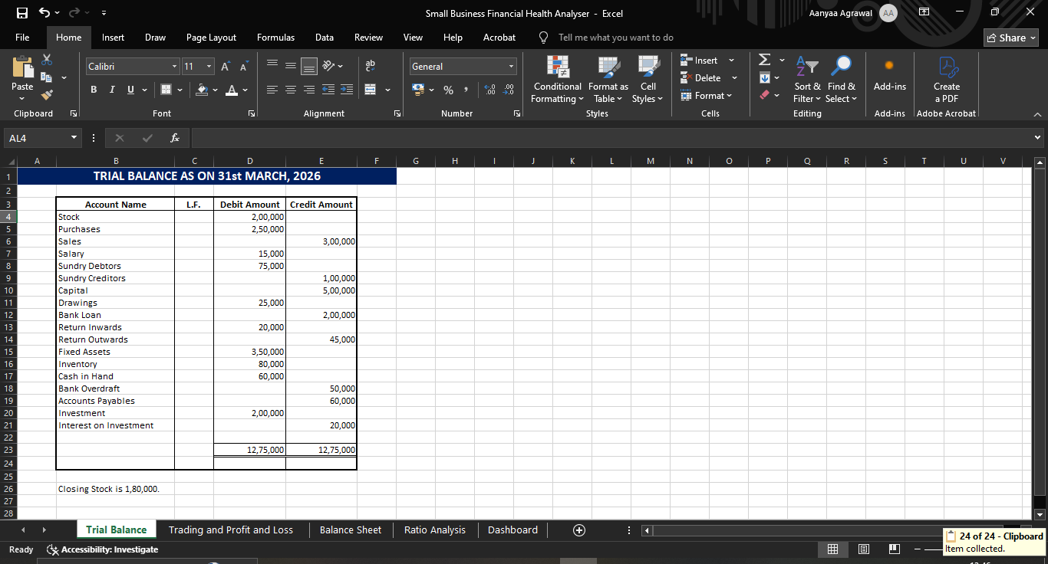

Trading and Profit and Loss Account

A trading account is a financial statement used to calculate a business's gross profit or loss from buying and selling goods. It acts as the first step in preparing a company’s final accounts by focusing strictly on direct revenues and the direct costs associated with those goods. A profit and loss account, formally known as an income statement or simply as a P&L, tracks the amount of profit that remains after a business subtracts all of its costs from its revenue during a specific accounting period, typically monthly, quarterly, and annually.
The trading account and the income statement are important because it measures business profitability, assists in cost control, helps evaluate operational efficiency, and supports decision-making regarding pricing and expenses.
It was seen that:
- The business has net sales amounted to ₹2,80,000.
- Gross profit earned was ₹55,000.
- Net profit earned was ₹60,000.
- Interest income from investments contributed positively to profitability.
By analyzing the statement, it can be said that the business generated a satisfactory profit level and effectively managed its operating expenses.

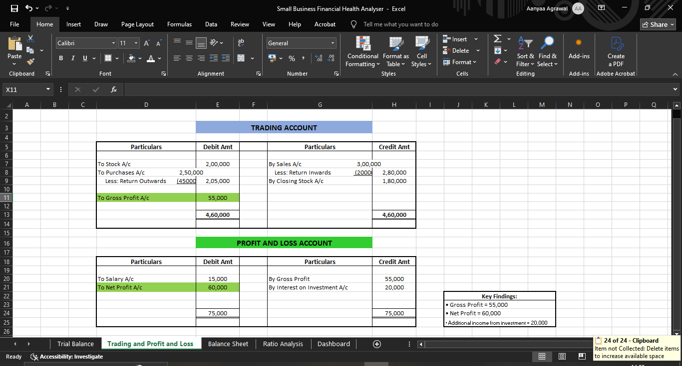

Balance Sheet

A Balance Sheet is a core and important statement that shows the financial position of the company at a specific point of time. It details everything the business owns (assets), everything it owes (liabilities), and the owners' stake (equity/capital).
It is the most important and crucial financial statement because it shows the financial position of the company, assesses solvency, evaluates liquidity, and also helps investors and lenders assesses business stability.
In the balance sheet of Agrawal Traders, asset side included both current assets and non-current assets and for the liabilities side, it included equity, current liabilities and long term liabilities. It was seen that the total assets and total liabilities of the company are equal at ₹9,45,000.
It can be said that the business maintains a balanced financial structure with moderate debt and adequate asset backing.

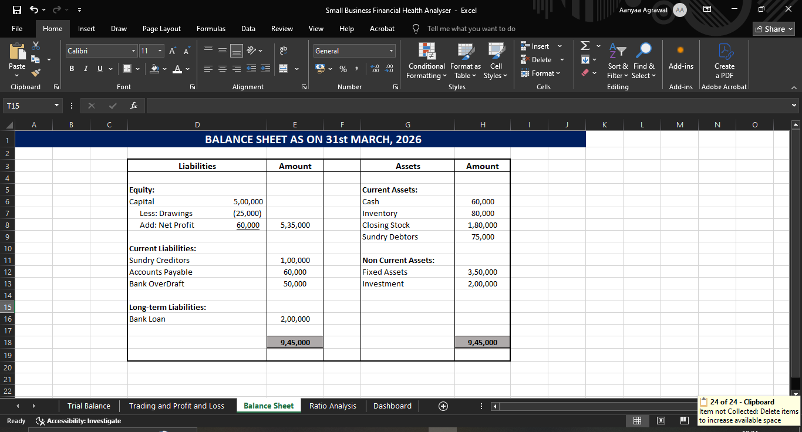

RATIO ANALYSIS

Ratio Analysis establishes a numerical or quantitative relationship between two items of financial statements to provide a meaningful understanding of the profitability and financial position of an enterprise.

Current Ratio

This ratio explains the relationship between the current assets and the current liabilities of a business. It can be calculated by:
$$Current Ratio= \frac{Current Assets}{Current Liabilities}$$
This ratio is used to assess the firm’s ability to meet its short-term liabilities on time. The ideal current ratio is considered as 2:1. The higher the ratio, the better it is because the firm will be able to pay its current liabilities more easily.
The current ratio of this business was calculated as 1.88:1. This shows that the business possesses sufficient, but not ample, current assets to meet its short-term liabilities.

Quick Ratio

It establishes the relationship between liquid assets and current liabilities. ‘Liquid assets’ means those assets which will be converted into cash and cash equivalents very shortly. The ratio can be calculated by:
$$Quick Ratio= \frac{Liquid Assets}{Current Liabilities}$$
This ratio is used to measure the ability of the firm to meet its current liabilities immediately or with a month. The ideal ratio is 1:1. This ratio is a better test of short-term financial position of the company than the current ratio, as it considers only those assets which can be easily and readily converted into cash.
The liquid ratio of this business is 0.64:1. This shows weak immediate liquidity and it depends highly on inventory to meet its short-term liabilities.

Net Profit Margin

This ratio shows the relationship between net profit and net sales also known as revenue from operations. The formula to calculate this is:
$$Net Profit Margin= \frac{Net Profit}{Net Sales} × 100$$
It is used to measure profitability of the company. Investors use net profit margin to gauge a company's financial health and growth potential. The net profit margin percentage above 20% is considered excellent. This shows the percentage of revenue remaining as profit after deducting all operating expenses, taxes, and interest.
The net profit margin for the Agrawal Traders is 21.43% showing strong profitability. It indicates effective cost management and healthy business operations.

Debt Ratio

In this ratio, long-term debts are expressed in relation to total assets. It is calculated as under:
$$Debt Ratio= \frac{Debt}{Total Assets}$$
The ideal ratio is 2:1. It measures the extent to which long term loans are covered by assets. A lower debt ratio implies the use of lower debts in financing the assets which means a larger safety margin for lenders.
The debt ratio for this business is 0.43 which shows that the business maintains a moderate and manageable level of debt.

Debt Equity Ratio

This ratio expresses the relationship between long-term debts and equity. It is calculated by:
$$Debt Equity Ratio= \frac{Long term Debts}{Equity}$$
This ratio is calculated to assess the ability of the business to meet its long-term liabilities. Lower than 2:1 debt equity ratio provides sufficient protection to long term lenders.
This business has its debt equity ratio of 0.77 which is sufficient to meet its debts.

Inventory Turnover Ratio

This ratio indicates the relationship between the cost of revenue from operations during the year and average inventory kept during that year.
$$Inventory Turnover Ratio=\frac{Cost of Revenue from Operations}{Average Inventory}$$
This ratio indicates whether the inventory has been efficiently used or not. The ratio above 5 is considered ideal. The higher the ratio, the better it is, since it indicates that inventory is selling quickly.
The inventory turnover ratio for this business is 2.25. This shows that inventory does not sell quickly and remains lying in godown for quite a long time. This results in increased storage costs, blocking of funds and losses on account of goods becoming obsolete or unsaleable.

Return on Investment

This ratio reflects the overall profitability of the business. It is calculated by:
$$Return on Investment= \frac{Net Profit}{Cost of Investment} ×100$$
An ideal percentage rate for return on investment ranges between 10% and 20%. A high ROI means your investment generate significant net profit relative to their costs.
As seen, this business evaluates 10% which is considered good and indicates that it relies on high sales volume rather than massive profit margins, making this highly sustainable.

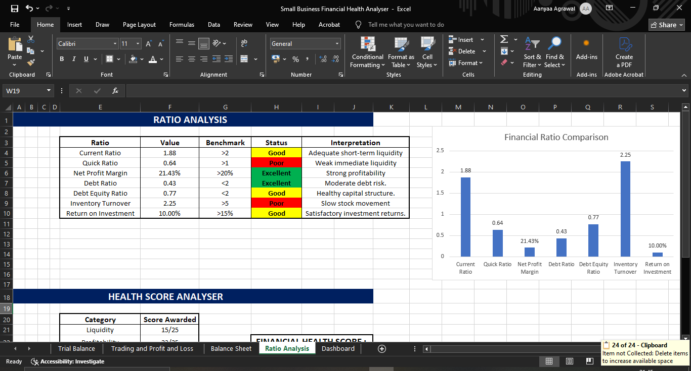

FINANCIAL HEALTH SCORE MODEL

A financial health score gives you an idea of how you manage your money. It tracks your spending, savings, debt, and investments. It was developed to summarize the overall financial performance of the business.
The model evaluates four major areas:
- Liquidity - Liquidity measures how well a company can cover short-term liabilities. This means the company can pay its debts without having to borrow money from outside. It is a vital component of credit, financial health, and bankruptcy-prediction models. It can be measured with the help of Current ratio and Liquid Ratio.
- Profitability - Profitability measures a business's ability to generate earnings relative to its revenue, operating costs, and assets. It is evaluated using specific margin and return ratios to see if a business is making use of its money and assets and if it can make money for a long time. It is measured using Net Profit Margin and Return on Investment.
- Efficiency - Efficiency is the ability of an organization or individual to maximize financial returns using the minimal amount of resources. It can be measured using Inventory Turnover Ratio.
- Solvency - Solvency measures an entity's ability to cover its long-term liabilities and sustain operations. It helps us to analyse if a company can handle its debt, in the run we need to look at its total assets and compare them to its total obligations. This will help us predict if the company is, at risk of going bankrupt. It can be evaluated using Debt Ratio and Debt to Equity Ratio.
In this financial model, each category was scored based on their performance level as follows:

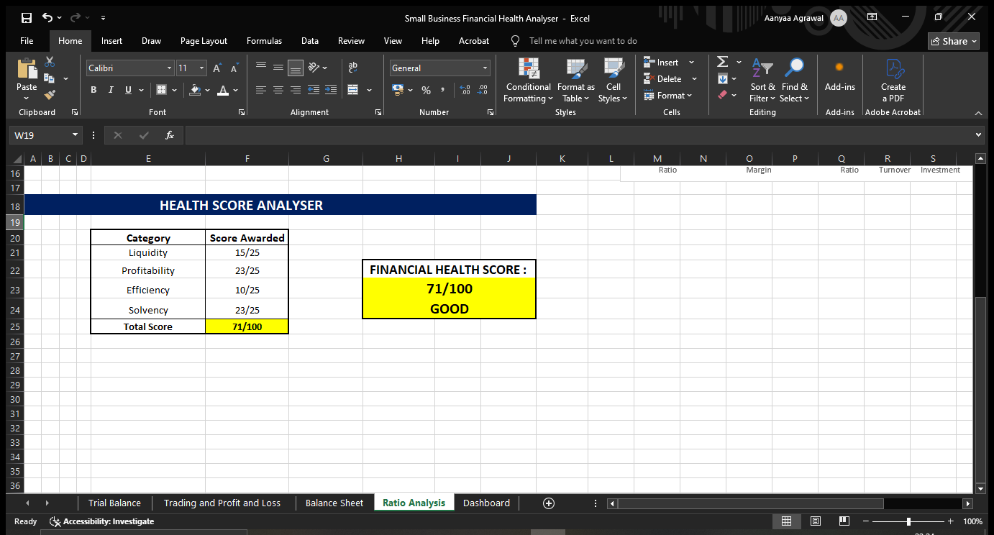
A score of 71 out of 100 shows that Agrawal Traders is in good financial position with strong profitability and manageable debt levels. However, the business needs to improve its liquidity level by keeping more cash in hand and managing its inventory.

DASHBOARD

A financial dashboard is a reporting tool that consolidates and displays key financial data in a single view. Its purpose is to provide a quick overview of the organization’s financial performance, typically including metrics such as revenue, expenses, profit, cash flow, and liquidity ratios. It transforms raw accounting and transactional data into digestible charts, graphs, and widgets, enabling quick performance monitoring and strategic decision-making.
A dashboard is important because it provides quick insights, helps to improve and strengthen decision-making, simplifies complex financial information, enhances presentation and reporting quality and improves user understanding through visualizations.
This dashboard includes Key Performance Indicator (KPI) cards, Ratio Analysis Chart, Financial Health Score Chart, Key Findings about the business, and Strengths and Weaknesses.

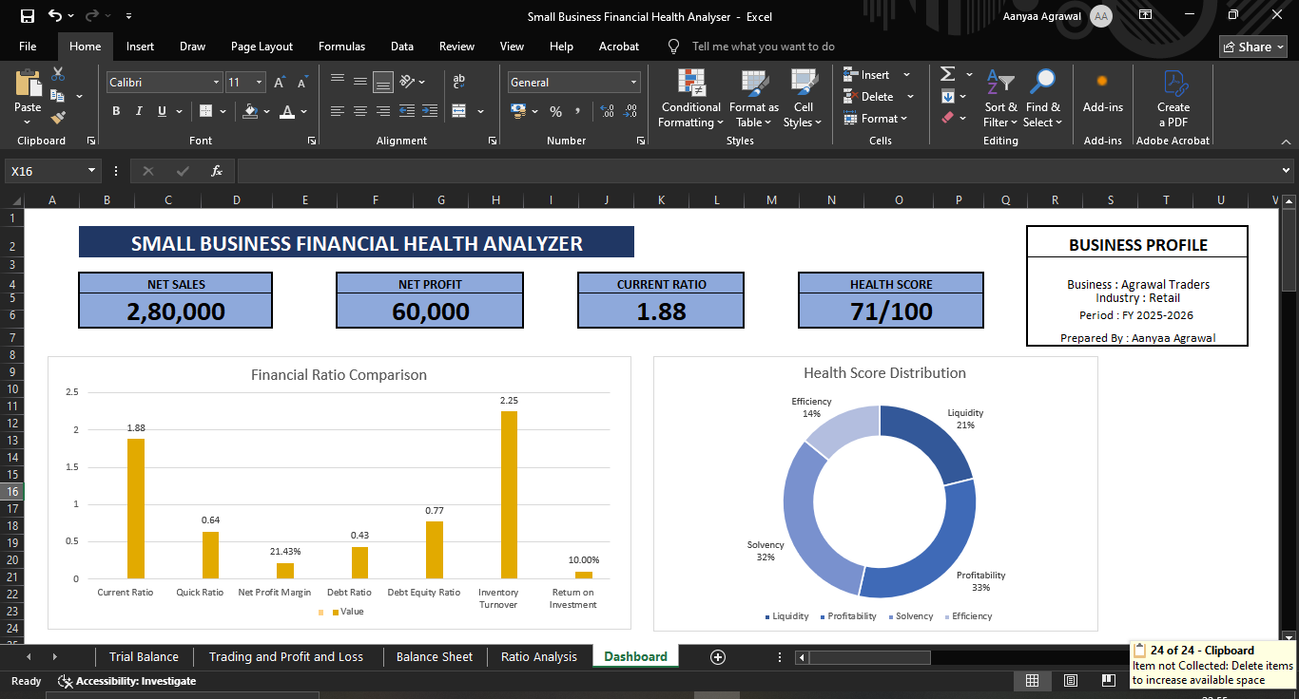
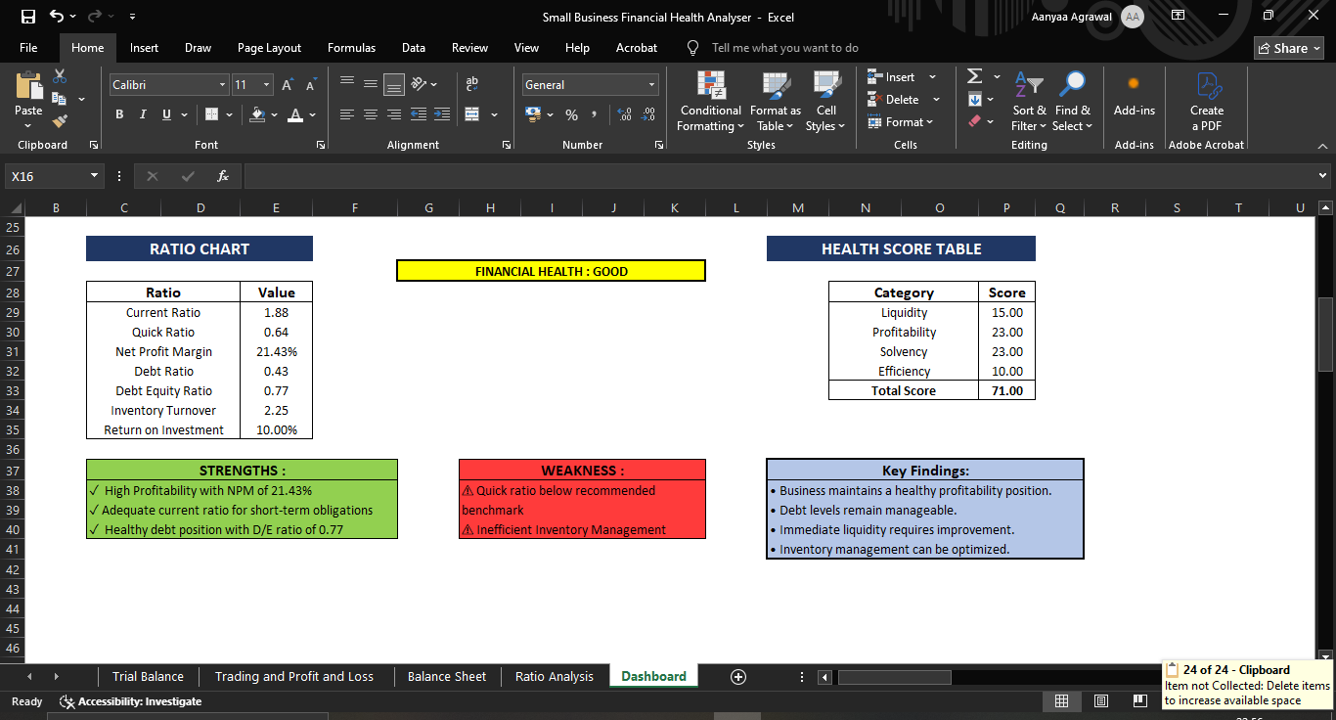

Dashboard Insights:
- Strong profitability performance
- Moderate debt burden
- Good overall financial health
- Weak inventory efficiency
- Improvement needed in quick liquidity

FINDINGS

While preparing the financial statements, financial analysis, and health score model, these are a few things that can be depicted:
- The business is profitable with a Net Profit Margin of 21.43%.
- Current ratio indicates sufficient but not excessive liquidity.
- Quick Ratio reveals high dependency on inventories.
- Debt levels are moderate and manageable.
- Debt-to-Equity Ratio indicates a healthy capital structure.
- Inventory Turnover Ratio is relatively low indicating inefficient inventory management and slow stock movement.
- ROI is satisfactory.
- Overall financial health score is 71/100 indicating good financial condition.
- The business demonstrates financial stability.

RECOMMENDATIONS

A garment business is very competitive in today’s world. Several drawbacks are interpreted in the retail garment business of Agrawal Traders. To thrive in this industry, it must keep in mind and consider following things:
- Improve quick liquidity by maintaining higher cash reserves.
- Reduce dependency on inventories for meeting liabilities.
- Implement better inventory control system.
- Introduce faster-moving garment collections.
- Monitor inventory aging regularly.
- Increase marketing efforts to improve sales turnover.
- Review investment opportunities to enhance ROI.
- Maintain current profitability levels through cost control.
- Continue managing debt prudently.
- Conduct regular financial analysis and dashboard monitoring.

CONCLUSION

The project successfully analysed the financial health of Agrawal Traders through financial statement preparation, ratio analysis, and financial performance evaluation.
The analysis revealed that the business is financially stable, profitable, and capable of meeting most of its obligations. The Net Profit Margin and debt-related ratios indicate strong financial performance, while the Quick Ratio and Inventory Turnover Ratio highlight areas requiring immediate attention.
The Financial Health Score Model provided an overall score of 71/100, indicating a good financial condition. The dashboard effectively transformed financial data into meaningful visual insights, making analysis easier and more accessible.
This project enhanced practical understanding of accounting, financial statement analysis, ratio interpretation, and Excel-based dashboard creation. It demonstrates how financial data can be used to evaluate business performance and support informed decision-making. It showed me how important it is to look at a company’s financial health.

